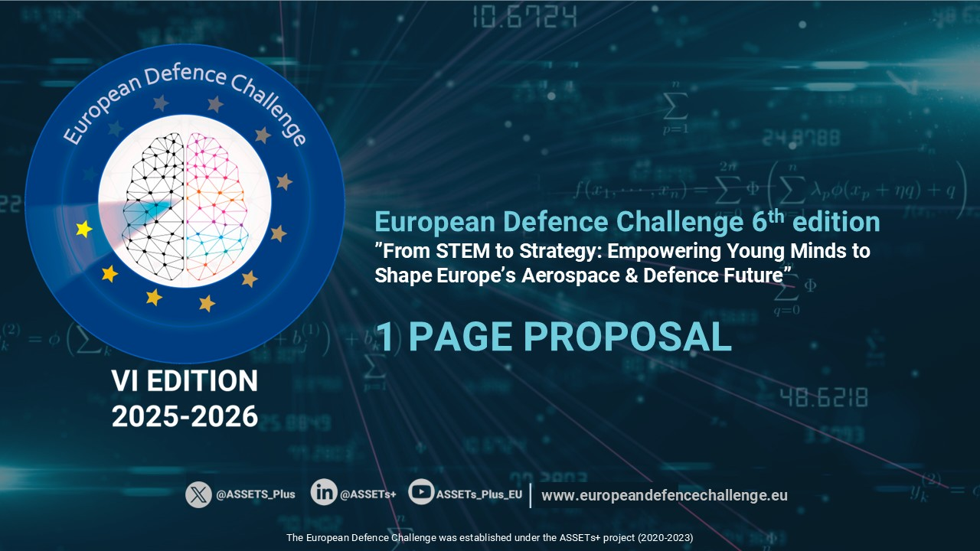
s
4ISTAR

This is the template for the 1 page proposal (500-600 words).  If your proposal is selected for the second stage of the Challenge, you will be asked to expand the description to 10 pages (5000-6000 words) which should be a development of the previously submitted proposal.  IMPORTANT: Students are strongly encouraged to team up in pairs, finding a partner in a different university or country. Teams will get an additional point in the final score.  A fresh view is valued. Please, defend your proposal by including not only technological, but also socio-economic, political, ethical and environmental aspects.  SEND TO: challenge@assets-plus.eu | Participant # 1  Name Click or tap here to enter text.  University/Institution Click or tap here to enter text.  Country Click or tap here to enter text.  Email Click or tap here to enter text.  Participant #2  Name Click or tap here to enter text.  University/Institution Click or tap here to enter text.  Country Click or tap here to enter text.  Email Click or tap here to enter text.

Subject/title of your proposal: Click or tap here to enter text.
Proposal description (one page)

