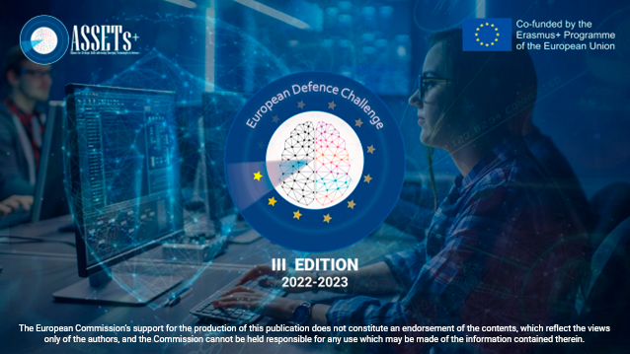

4ISTAR

The Challenge  The European Commission has declared technology as the EU’s top priority for the next five years. More particularly, one key objective is the mastery and ownership of key technologies in Europe.  With this objective in mind the European Defence Challenge asks the students of Europe to propose one or more work approaches dealing with topics such as artificial intelligence, autonomous vehicles, batteries, cybersecurity, chip technologies, control, robotics, signal and image processing, and related to defence technologies within the framework of the question mentioned above.  Please, defend your proposal by including not only technological, but also socio-economic, political, ethical and/or environmental aspects.  SEND TO: challenge@assets-plus.eu before midnight CET February 14, 2023. | Participant # 1  Name Click or tap here to enter text.  University Click or tap here to enter text.  Country Click or tap here to enter text.  Email Click or tap here to enter text.  Participant #2  Name Click or tap here to enter text.  University Click or tap here to enter text.  Country Click or tap here to enter text.  Email Click or tap here to enter text.

Subject/title: Click or tap here to enter text.
Proposal description (10 pages)

